ALL ARE INVITED

SCHOOL OF ARTS AND AESTHETICS, JAWAHARLAL NEHRU UNIVERSITY
PRESENTS

Love in the Time of Choleric Capital

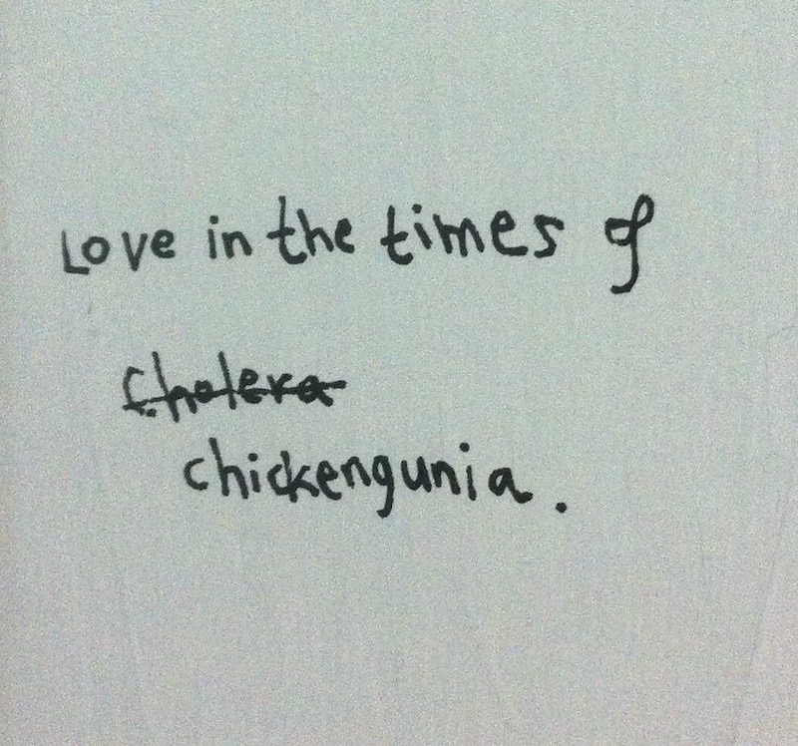
Gagan Singh, Moment Enough (detail), site specific drawings at SAA, JNU, 2016

________________________________________________
With Agha Shahid Ali, Akshay Manwani, Aman Sethi, Ambarish Satwik, Anant and MK Raina, Ayodhya Sahmat, Faiz Ahmed Faiz, Felice Beato, Gagan Singh, Gitanjali Dang, Himali Singh Soin, John Murray, Kush Badhwar, Lorena Herrera Rashid, Mac Robber, Mona Gandhi, Mustansir Dalvi, Naman Ahuja, Nirmal Kulkarni, Phalguni Desai, Rashmi Sawhney, Raul Irani, Raqs Media Collective, Rehaan Engineer, Sahir Ludhianvi, Sarover Zaidi, Simit Raveshia, Sudarshan Shetty, Superflex, The Temple Project (Adiv Pure Nature), Vishal K Dar, Zohra Segal, Zuleikha Chaudhari
Address: School of Arts and Aesthetics Gallery, Jawaharlal Nehru University, New Mehrauli Road, Near Munirka, New Delhi, Delhi: 110067
Opening: Friday, October 14, 6.30 pm
Dates: Oct 15–Nov 15, 2016
Hours: 10 am–7 pm, Monday to Saturday, closed on Sunday and gazetted holidays
________________________________________________
This exhibition was occasioned by an encounter between:
1. The 17th century marble Mahal made at the order of emperor Shah Jahan
2. Poet-lyricist Sahir Ludhianvi’s balls-to-the-wall response to the Taj
3. And, retired postmaster general Saidul Hasan Qadri’s Maqbara Yaadgare Mohabbat; a ‘replica’ of the Taj currently under construction
*
From Rabindranath Tagore to Rudyard Kipling to Eleanor Roosevelt, there is an appropriately glowing and indefinitely large body of literature addressing the Taj. The contrariness of Ludhianvi’s poem, titled after the monument and written in 1943, stands at a distance from the reams written in praise. In the poem, Ludhianvi urges his lover to meet him someplace other than the Taj because the mausoleum is the symbol of an emperor’s vanity and imperious love.
Two decades later, Ludhianvi wrote the lyrics for the film Taj Mahal. Here the contrarian is missing. Instead we find glowing words in service of the Shah Jahan-Mumtaz Mahal romance; Ludhianvi even won the ‘best lyricist’ award for his work on the film.
A little less than five decades later in Kaser Kalan—a village in Dibai tehsil approximately 150 kms outside of Delhi—Saidul Hasan Qadri began work on a maqbara in the memory of his wife Tajammuli Begum. The couple were childless and Begum feared that their graves would go unvisited. And so Qadri promised her a mausoleum that would bring people to their graves.
The skyline of Dibai has yet to see a building like Qadri and Begum’s Maqbara Yaadgare Mohabbat (Tomb in the Memory of Love). No sooner had the production begun than people started referring to it as the Taj Mahal (Crown of Palaces). And not for nothing too, the Maqbara bears more than a passing resemblance to the Taj, which Qadri has visited on more than one occasion.
Work on the Maqbara is currently stalled because Qadri, who turned 80 in July this year, has already spent his life savings, i.e. Rs 10 lakh, on its construction.
*
The intertwined stories of the opening encounter were sent out as probes and over time these probes returned with traces, segments, pathologies of kaleidoscopic situations. The exhibition is a coproduction of these situations, with its ‘centre’ getting reconfigured in and with every situation.
- GD
An earlier iteration of the exhibition opened in Mumbai in 2014.
________________________________________________
HAPPENINGS
The Happenings will take place in and around School of Arts and Aesthetics Gallery and the venue will be announced at the Gallery on the given day. Chai will be served half-hour prior to each event.
October 19, 6.30 pm
Sarover Zaidi:
Working with Architecture and Language
A deliberation on Delhi, with its spaces of love (monumental Ruins) and its language of love (Urdu)
October 26, 6.30 pm
Anant Raina, Gagan Singh, Gitanjali Dang, Raqs Media Collective, Vishal K Dar and Zuleikha Chaudhari
Walkthrough
Artists and curator and LITTOCC
Date TBD
Aman Sethi
Love, Riots and Restlessness
The unsettling passions of West UP's youth
November 2, 6.30 pm
Naman Ahuja
Transgressive Love, Language and Lore during the Sultanate period
Is focused on Chandayana, a folk-ballad about ‘adulterous love’ recited in Central India, that during the 14th and 15th centuries made a serious bid to become a canonised Sufi text
November 4, 6.30 pm
Akshay Manwani
Cinematic Conscience
The talk considers the case of socio-politically engaged songwriters; beginning with Sahir Ludhianvi and his contemporaries, followed by a quick run right up to the current lot.
November 5, 6.30 pm
Rashmi Sawhney
Objects of Desire
Considers ‘love-objects’, within and without LITTOCC, to explore the relationship between affect and curatorial practice.
November 12, 6 pm onwards
Gitanjali Dang
6 pm: The world is full of paper. Write to me.
A letter to Agha Shahid Ali
Ambarish Satwik
7.15 pm: The Medical Nude
Deconstructs the libidinal as found in the nude of medical literature and imagery.
November 15, 6.30
Himali Singh Soin
To Tehran in my Dreams
In addressing the curatorial proposition of distance and its channels of longing, the performance reflects back on the mishaps of telegraphic messages to produce an illogical and surreal narrative, made up of digressions, divergences and stops.

is an itinerant arts lab founded in Mumbai in 2012 by curator and writer Gitanjali Dang. Defining the ‘aboutness’ of Khanabadosh is an existential crisis no less. It can, however, be said with some certainty that Khanabadosh lives off latitude, magic and agnosticism. It is interested in everything. It is particularly interested in constantly rethinking what it—and everything around it—is about.

Our mailing address: projects@khanabadosh.info
For more information visit: khanabadosh.info & draftprojects.info
Want to change how you receive these emails?
You can update your preferences or unsubscribe from this list

